Intentional bugs  
Acme-Chorbies 2.0

Provide the title and version of the project to which this document applies.

|  |  |
| --- | --- |
| ****Development team**** | |
| **Identifier** | Acme-RSNF |
| **Members** | Barrientos Mohedano, Rubén  Egea Guerrero, Simón  García da Silva, Felipe Javier  Lorenz Rosado, Nicolás |
| **Testing team** | |
| **Identifier** | Write the identification of your testing team. |
| **Members** | List the members of your testing team. |
| **Indexing data** | |
| **Designers** | Barrientos Mohedano, Rubén  Egea Guerrero, Simón  García da Silva, Felipe Javier  Lorenz Rosado, Nicolás |
| **Testers** | List the people who have conducted the tests. |
| **Notes** | Add notes if necessary. |

List person names using the following pattern: Surname, Name.

|  |
| --- |
| ****Effectiveness**** |
| Document the effectiveness of your testers. Compute it as the ratio of intentional bugs that they've found to the total number of intentional bugs that you injected. |

Table of contents

Use case 3- Listar los chorbies registrados en el sistema 2

Use case 5.4- Editar el perfil de un usuario (Cancelar) 3

For every use case in which you have included an intentional bug, add a page with the following structure.

# Use case 3- Listar los chorbies registrados en el sistema

Write the code and the name of your use case in the title.

Description

A la hora de listar los chorbies, no se va a mostrar la foto de dichos chorbies.

Bug:

Aqui vemos como la foto no se muestra

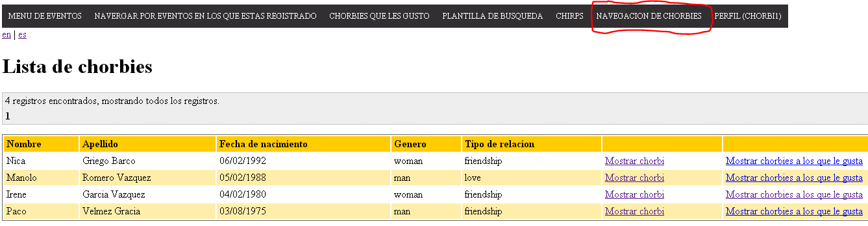

Original:

Pero en la vista original, sí

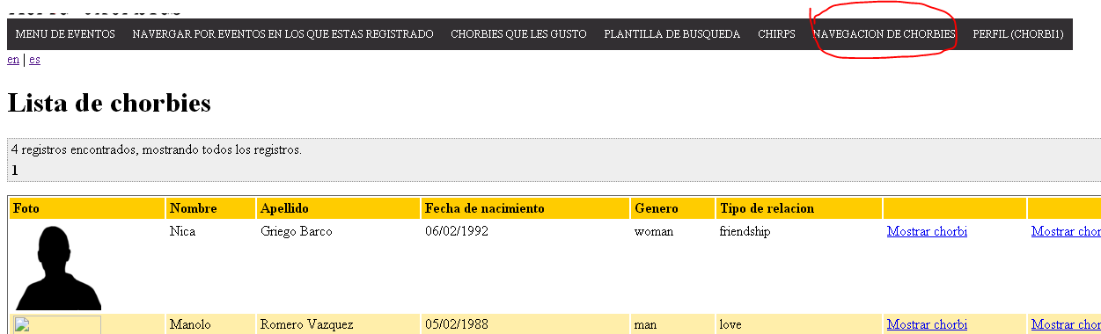

Results

Comment on whether the tester found this bug or not.

# Use case 5.4- Editar el perfil de un usuario (Cancelar)

Write the code and the name of your use case in the title.

Description

Cuando se pulse el botón de cancelar al editar el perfil, se redirigirá a un lugar incorrecto

Bug:

Estamos en la vista de editar perfil

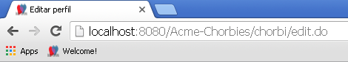

Pulsamos el botón de cancelar



Y nos redirige a tu perfil, lo cual está mal

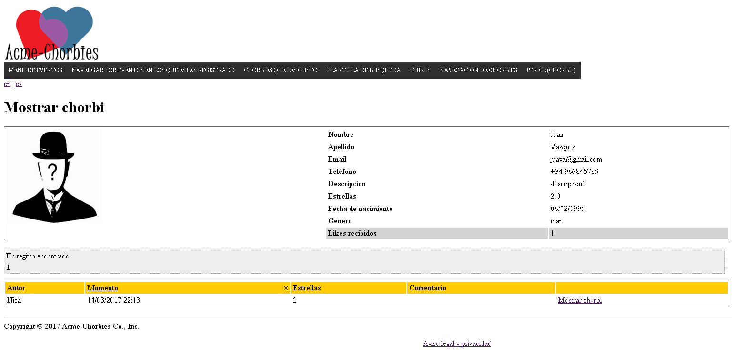

Original:

Estamos en la vista de editar perfil al igual que antes, pulsamos el botón de cancelar y nos lleva a la página principal del sistema.

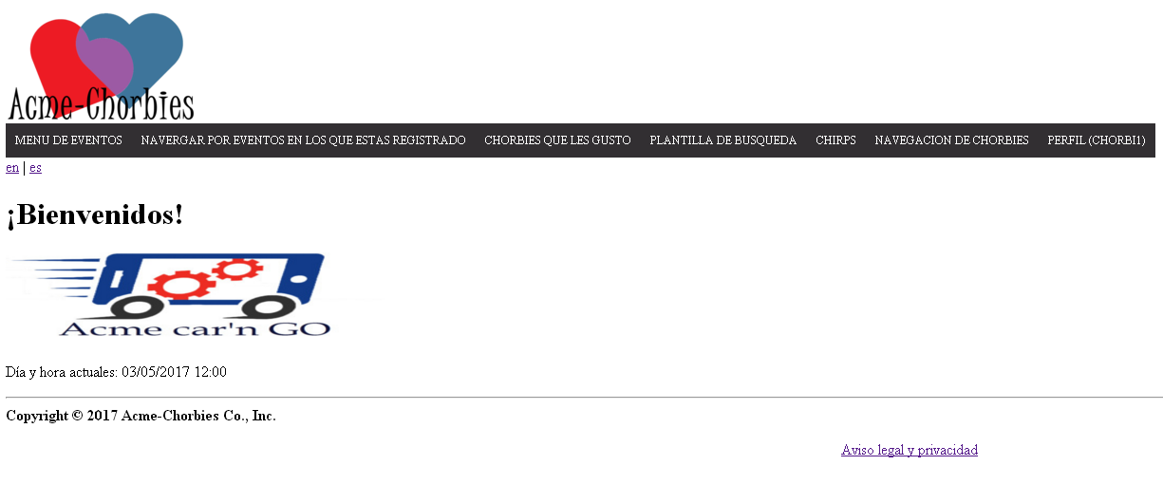

Results

Comment on whether the tester found this bug or not.

# Use case 7.6 – Cambiar banners mostrados (Guardar en blanco)

Write the code and the name of your use case in the title.

Description

Se va poder guardar en blanco un banner

Bug:

Si dejamos en blanco el campo de la URL, se guardará el banner en blanco

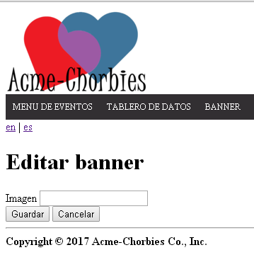

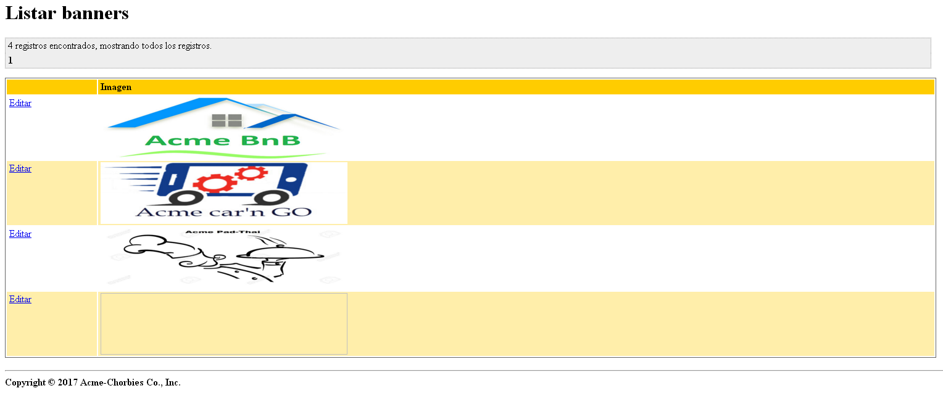

Original:

En el original, no puedes dejarlo en blanco

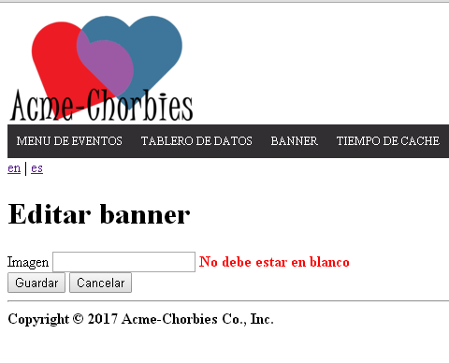

Results

Comment on whether the tester found this bug or not.